**Bike Route Optimization. Joe Hardy is a W. P. Carey student and lives at 12Fifty5 on East University Drive. He rides his bike to school every day. Once, network flow models were taught to him, he was curious to minimize the time taken by him to reach McCord Hall from 12Fifty5. The average speed at which he rides is 5 ft/sec. Stop boards add 3 sec. and Signals add 45 sec. to the travel time. Stop boards are placed on network arcs meaning only if you travel through that arc it will affect you but, traffic lights are placed on nodes meaning whichever route you take, If you are planning to reach a node with a light, it will affect you. Traffic lights will affect you only when you are going into a node and not when you are going out of one.**

***12Fifty5 to McCord Hall Google Map***

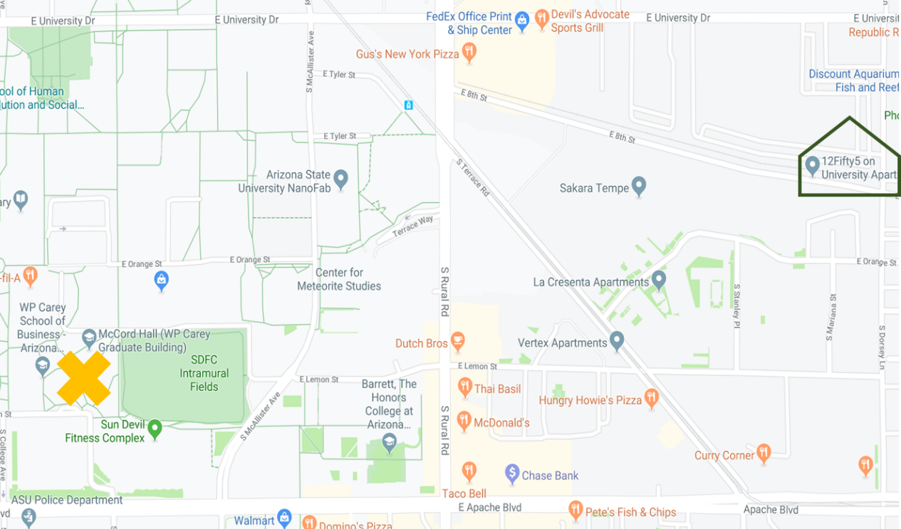

***Simplified Rendering of the above map***

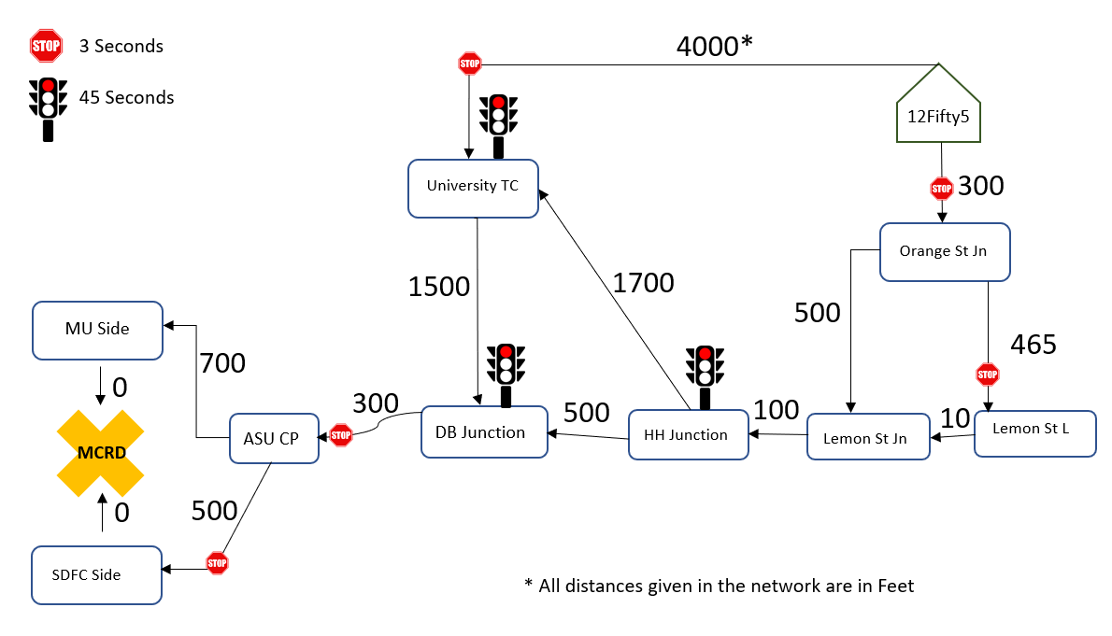

**Discussion. What makes this problem interesting is that instead of the traditional optimization on distance, it is asking us to minimize travel time. Also, being close to reality, we have stop boards and signals which add into the travel time.**

Method. Since average speed is constant, we can transpose the distance problem into a time problem with ease while retaining linearity in the model. Once we know the time taken to transverse each road, we can then add in the time in case faced with a stop board or a signal.

Now that we converted the problem into a simple shortest path network flow model, we can treat each junction as a node and do binary assignment on top of them to find the optimized path.

With the above approach, we can setup the following mathematical model.

**Model.**

Parameters:

Decisions:

,

Objective:

Constraints:

Notes:

1. The objective function captures the total travel time from the start at 12Fifty5 to the end at McCord Hall. The three terms represent the time taken to pedal, the time taken at stop boards, and the time taken at traffic lights
2. The Constraint (1) ensures that the net outflow from node 1 is 1 i.e. Hardy left 12Fifty5
3. The Constraint (2) ensures that the net inflow at node 11 is 1 i.e. Hardy reached McCord
4. The Constraint (3) ensures that the (net outflow – net inflow) at all the transition nodes is 0 i.e. we do not want Hardy to get stuck at one of the junctions: with this constraint in place, if Hardy enters a transition node, he will have to exit it for sure
5. The Constraint (4) ensures that there will be a binary assignment of routes i.e. Hardy either travels through an arc of the route or he doesn’t

**Optimal Solution. The following is the solution obtained from Excel Solver.**



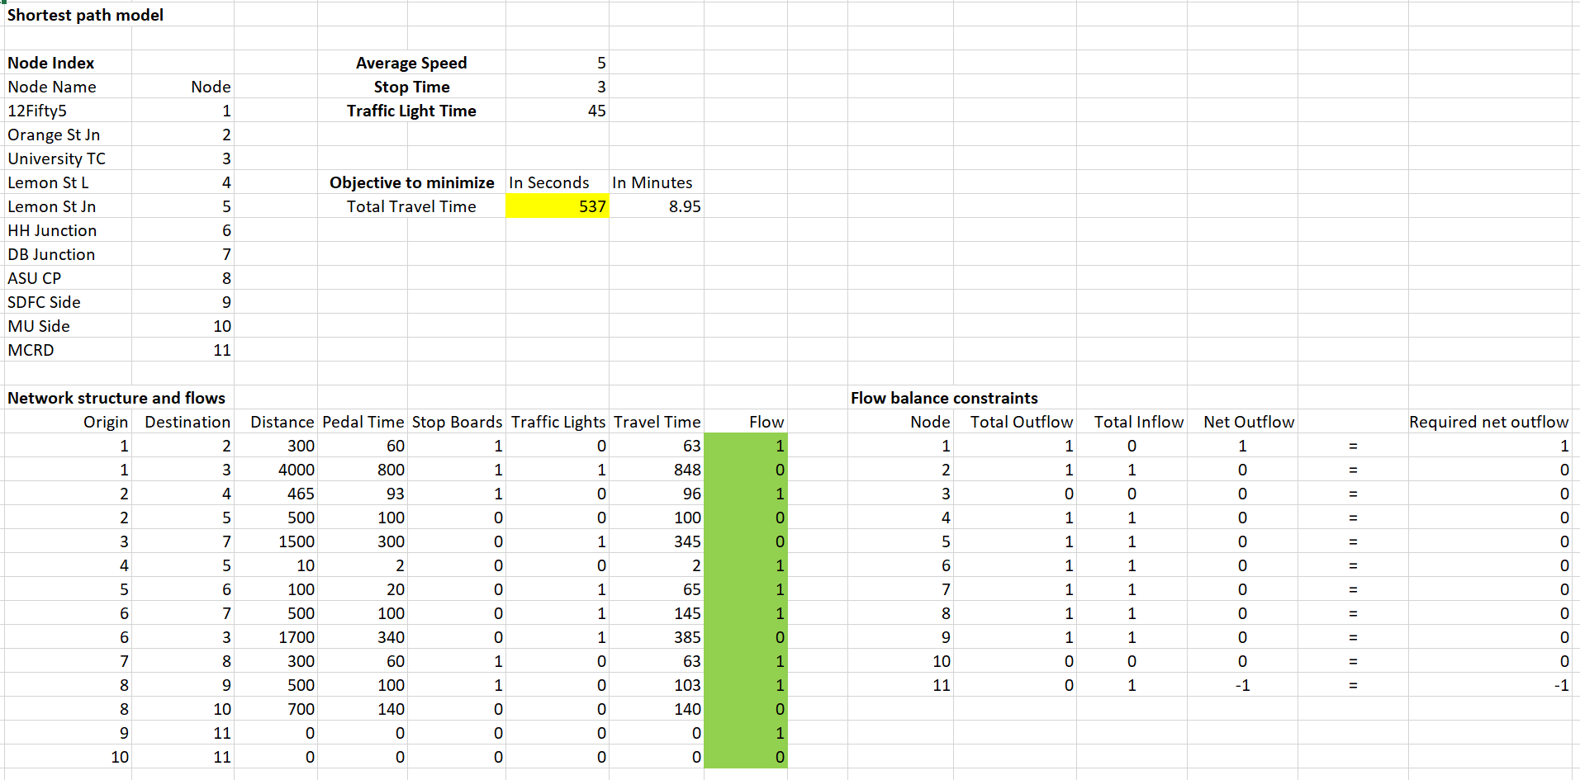

The Optimized route is

12Fifty5 → Orange St Jn → Lemon St L → Lemon St Jn → HH Junction → DB Junction → ASU CP → SDFC Side → MCRD

The same can be seen in the google map below

